**Set Up Selenium Grid**

**Step 2.5.1:** Setting up Selenium Grid hub

1. Download Selenium standalone Server jar file from <https://www.seleniumhq.org/download/> link

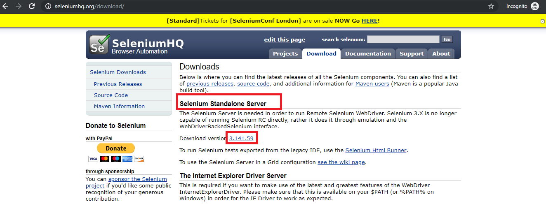

1. Save it in a folder
2. Go to command prompt
3. Navigate to folder structure where you have saved the Selenium standalone Server jar file
4. Type the below command in command prompt

**Java -jar selenium-server-standalone-3.141.59.jar -role hub** and click on **Enter** button

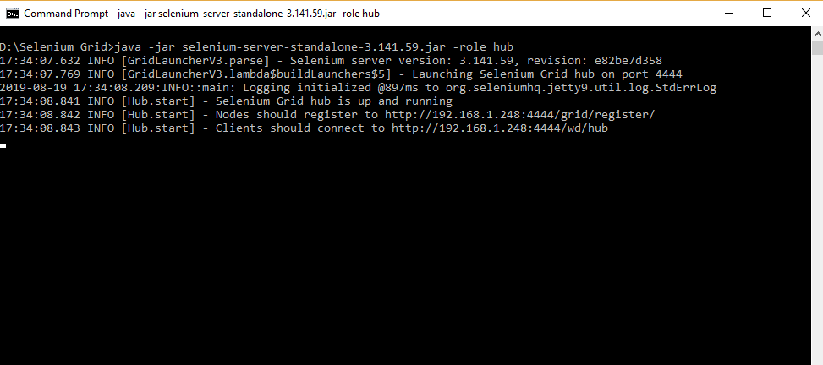

1. Open the Chrome browser
2. Enter URL as **http://localhost:4444/grid/console** and click on **Enter**
3. Grid console page is loaded as below

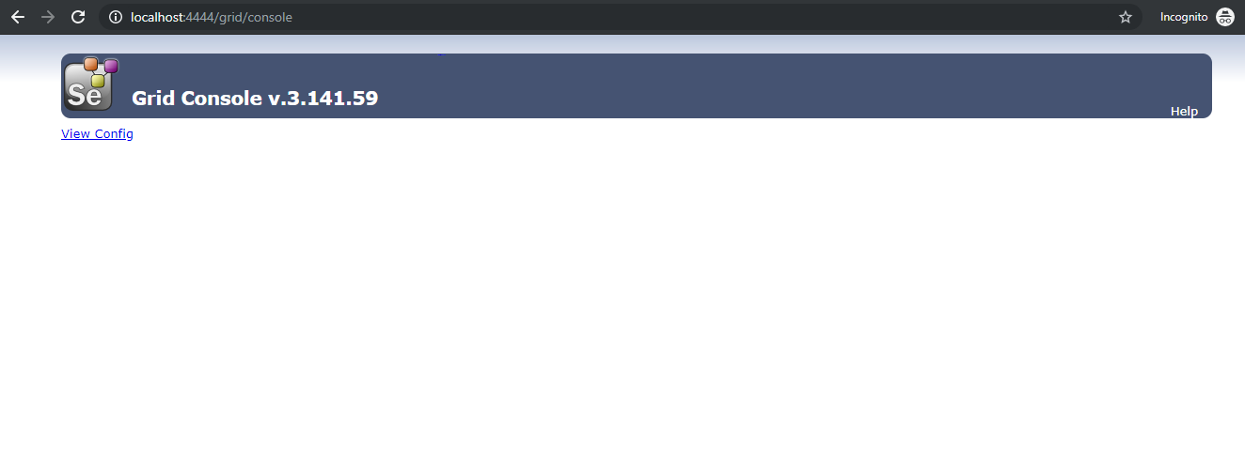

**Step 2.5.2:** Setting up the Selenium Grid Nodes

1. Once the Selenium Grid Hub is set up, the next step is to set up Selenium Grid nodes.
2. Open the new command prompt
3. Navigate to the folder structure where you have saved the Selenium standalone server jar file
4. Type the below command in command prompt

**java -jar selenium-server-standalone-3.141.59.jar -role node -hub** [**http://localhost:4444/grid/register**](http://localhost:4444/grid/register%E2%80%9D) and click on E**nter** button, which looks like

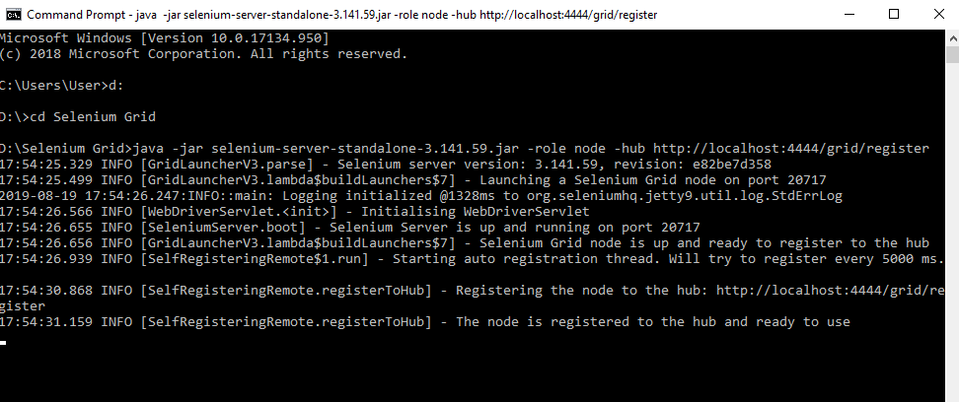

1. Open the browser
2. Enter URL as **http://localhost:4444/grid/console** and click on E**nter**
3. Grid console page is loaded below, which shows **Browsers** by default

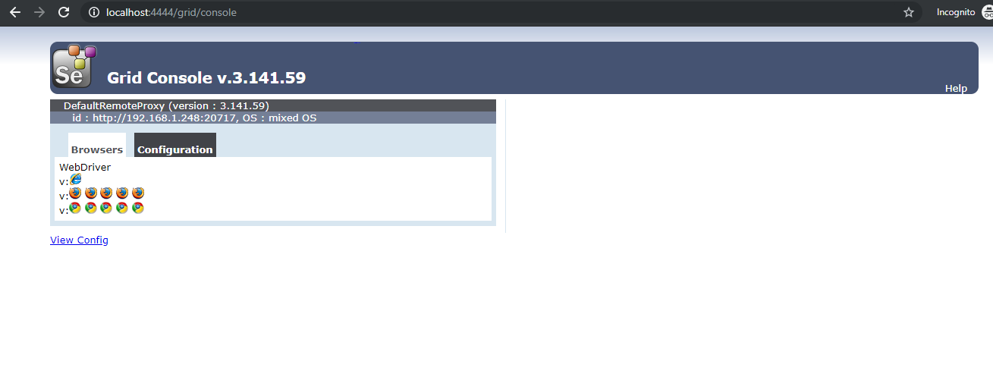

Click on **Configuration,** which shows Configuration details

